

**Name: Rian Bawazir**

**ID: 202111145**

**Name: Khaled Alanbar**

**ID: 202211365**

**Name: Khalid Mohamed**

**ID: 202211354**

**Hospital**

**Description**

Our project is about a Hospital which is located in Riyadh. It has more than one section, for each department there is a medical stuff. The hospital goal is to treat every patient with the most respect.

The hospital will consist of multiple department. The department will have a medical stuff and operation rooms. The hospital Accept All Patients. The hospital offers two types of payment either insurance or cash. The hospital record the medical history of the patient. A patient has to make an appointment when needing to visit a doctor.­­

**Entity:**

* Department: Department_ID (primary key), Department_Name.
* Medical_Staff: Staff _ID (primary key), Staff _Name, Staff _Specialty, Age, Salary.
* Patient: Patient_ID (primary key), Patient_Name, Date_Birth.
* Medical_History: Record_ID (primary key).
* Operation_Room: Room_ID (primary key).

**Relationship:**

* Department can have one or more medical staff, medical staff belong to one department.
* Medical staff must have one supervisor, supervisor can supervise one or more medical staff.
* Operating room may be assigned by one or more medical staff, Medical staff may belong to operating room.
* Medical history can be written by one or more medical staff, Medical staff can wright one or more medical history.
* Medical history must belong to one patient, patient must have one medical history.
* Medical staff may have many patients, patient can have one or more medical staff.
* Appointment number and a payment method is an attribute between medical staff and patient.

**EER Diagram:**

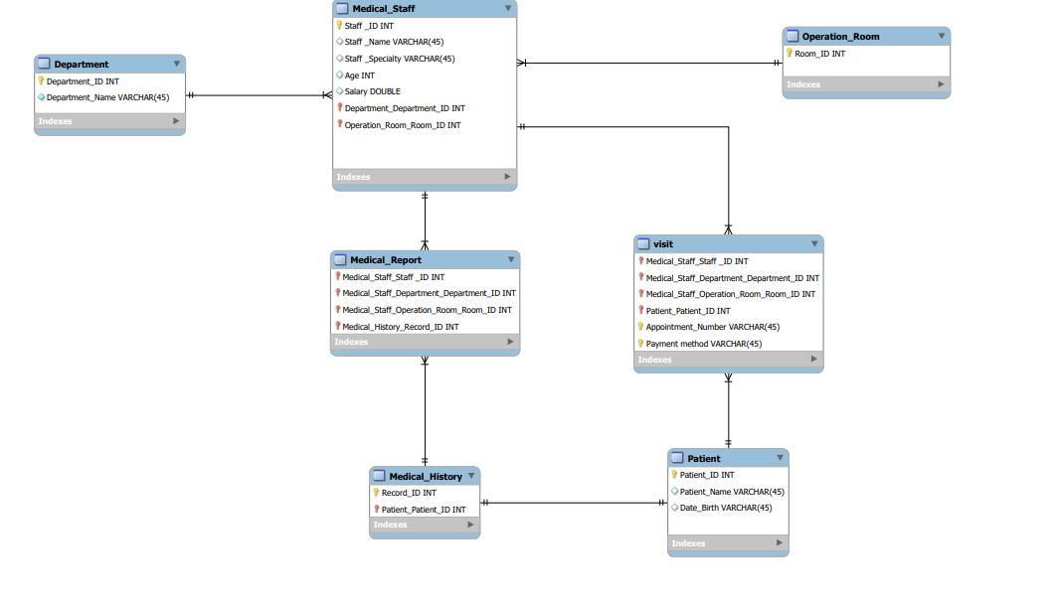

**Database Logical Design**

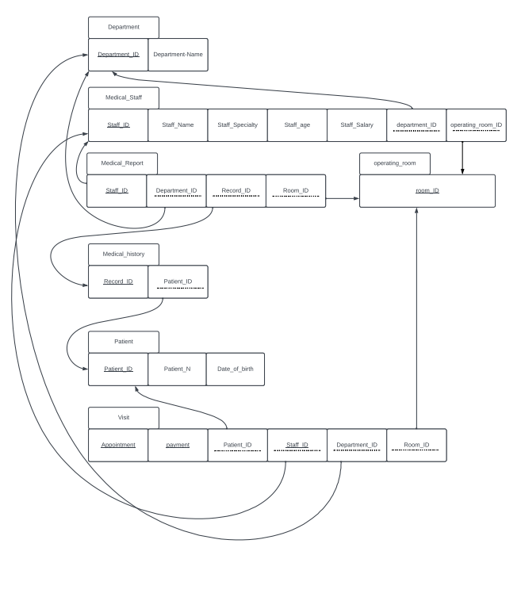

**Code:**



